A.
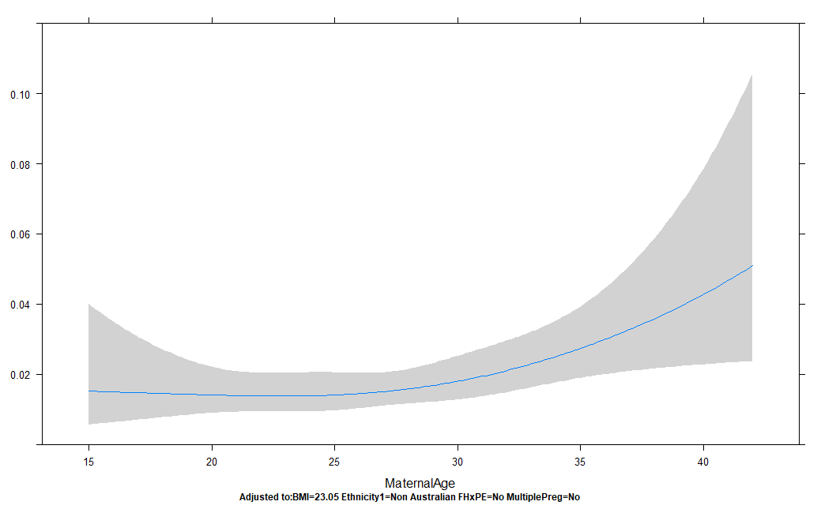
Probability of pre-eclampsia
Maternal age (years)

B.

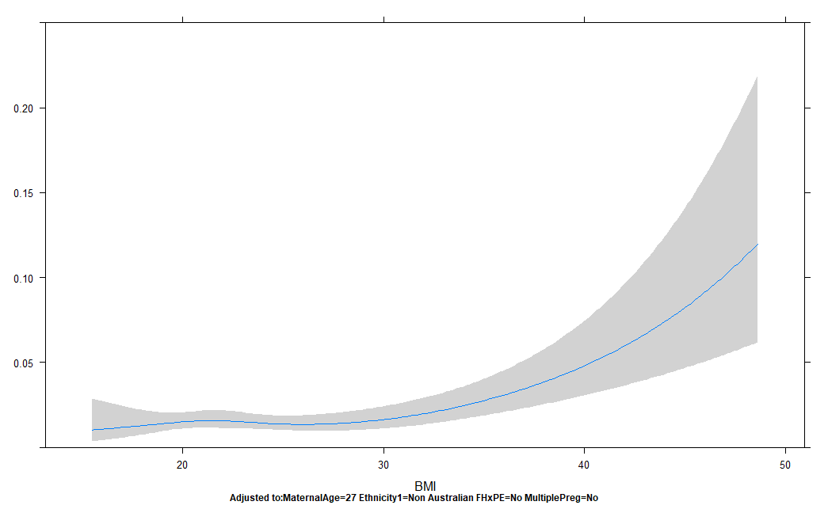
Probability of pre-eclampsia
Body Mass Index (kg/m²)

Fig. S1 Fitted trend between a continuous predictor and the logit pre-eclampsia using cubic spline function, Legend: (A) maternal age in years; (B) body mass index in kg/m²; all women (N=12,395)

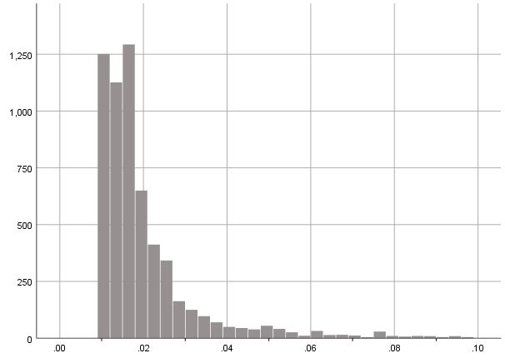
Frequency of women

Predicted probability of pre-eclampsia

Fig. S2 Distribution of predicted probabilities for pre-eclampsia using the Western Sydney (WS) base model in the validation sample excluding women with high-risk factors (N=6064)

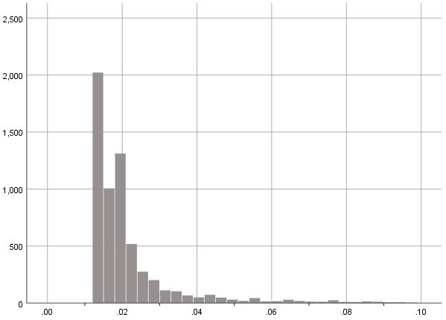
Frequency of women

Predicted probability of pre-eclampsia

Fig. S3 Distribution of predicted probabilities for pre-eclampsia using the Western Sydney (WS) full model in the validation sample (N=6201)

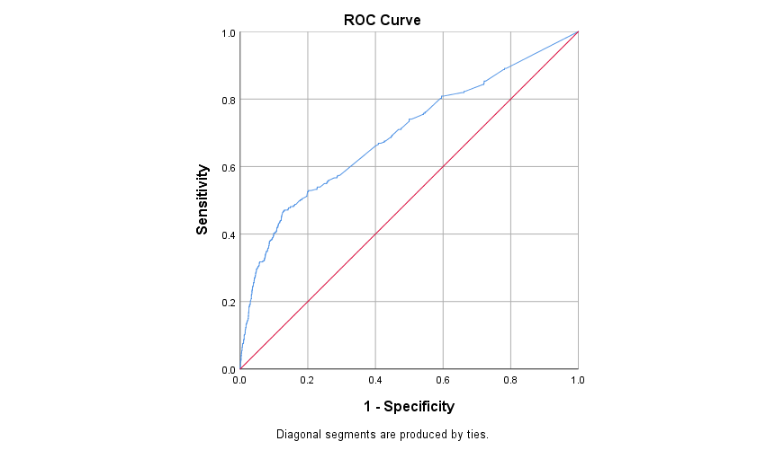

Fig. S4 Receiver-operator characteristic curve for the Western Sydney (WS) final model for prediction of pre-eclampsia in the entire study sample (N=12,395), area-under-curve 0.70 (95% CI 0.66-0.73)

